Eyes For The Blinds
Mr. Ashutosh Rajesh Upadhyay ^{*1}, Prof. Rahul Bhandekar ^{*2}, Asst Prof. Vijayta Dalwankar ^{*3}

^{*1} P.G Scholar Of Department Of Computer Science Engineering, Wainganga College of Engineering & Management, Nagpur, Maharashtra, India
aashuupadhyay99@gmail.com
^{*2} H.O.D. Professor, Department Of Computer Science Engineering, Wainganga College of Engineering & Management, Nagpur, Maharashtra, India
Bhandekar.r@wcem.edu.in
^{*3} Assistant Professor, Department Of Computer Science Engineering, Wainganga College of Engineering & Management, Nagpur, Maharashtra, India

dalwankar.v@wcem.edu.in
Abstract
Independent mobility remains a significant challenge for the approximately 2.2 billion individuals worldwide affected by visual impairment. Existing assistive navigation systems often rely on specialized ranging hardware, increasing cost and limiting scalability. This paper presents Eyes for the Blinds, a pure software-based assistive navigation framework that leverages a monocular camera and audio feedback to provide real-time environmental awareness. The proposed system integrates YOLOv8-based object detection with MiDaS monocular depth estimation to enable obstacle detection and distance perception without additional sensing hardware. A novel hybrid distance estimation approach is introduced, combining geometric lens- based calculations for known object classes with inverse depth mapping for general scene understanding. Furthermore, a human-centric audio interface converts metric distances into intuitive footstep-based navigation instructions. Experimental evaluation demonstrates an average object detection accuracy of 91.7%, real-time inference performance on edge devices, and distance estimation errors confined within ±5–10 cm in critical safety zones. These results validate the effectiveness of the proposed framework as a scalable, low-cost, and hardware- minimal solution for enhancing independent mobility among visually impaired individuals.
Keywords: Assistive technology, Deep learning, Edge computing, Monocular depth estimation, Object detection
- Introduction
Independent mobility is a fundamental prerequisite for personal autonomy and quality of life; however, it remains significantly compromised for individuals with visual impairments. According to global health reports, billions of individuals experience varying degrees of vision loss, restricting their ability to navigate safely in unfamiliar environments. Conventional mobility aids such as white canes and guide dogs provide immediate tactile feedback but are inherently limited in detecting elevated or dynamic obstacles and lack semantic awareness of the surrounding environment.
To overcome these limitations, Electronic Travel Aids (ETAs) have been proposed, integrating sensors such as ultrasonic modules, infrared detectors, LiDAR, and wearable hardware. While effective to an extent, such systems often suffer from increased weight, high manufacturing costs, energy inefficiency, and reduced scalability due to reliance on specialized hardware components. These constraints hinder widespread adoption, particularly in low-resource settings.
Recent advances in computer vision and deep learning have enabled software-driven environmental perception using passive visual sensing. Monocular camera-based systems offer an attractive alternative due to their low cost and ubiquity; however, accurate distance estimation from a single RGB image remains a fundamental challenge due to scale ambiguity, wherein absolute depth information cannot be directly inferred without additional viewpoints or active ranging sensors. Existing monocular approaches frequently trade accuracy for computational efficiency or require hardware augmentation to compensate for depth uncertainty.
This research addresses these challenges by proposing a pure software-based assistive navigation framework that achieves real-time semantic depth awareness using a single monocular camera. By integrating deep learning–based object detection with monocular depth estimation, the system eliminates the need for specialized ranging hardware while preserving spatial accuracy in critical safety zones.
The main contributions of this work are summarized as follows:
- A hardware-minimal assistive navigation framework utilizing only a monocular RGB camera and audio output.
- A novel hybrid distance estimation strategy combining geometric lens modeling for known object classes with inverse depth mapping for general scene understanding.
- Experimental validation demonstrating real-time inference on CPU-only platforms with distance estimation errors constrained within ±5–10 cm.

- Literature Review
Assistive navigation systems for visually impaired individuals have evolved significantly over the past decade, leveraging advancements in sensing technologies, embedded systems, and computer vision. Early Electronic Travel Aids (ETAs) primarily relied on ultrasonic and infrared sensors to detect nearby obstacles and provide tactile or auditory feedback. While these systems demonstrated low computational complexity, they were limited by narrow sensing range, poor angular resolution, and inability to provide semantic understanding of the environment.
To address these limitations, several researchers introduced LiDAR- and depth-sensor–based navigation frameworks capable of accurate distance estimation and spatial mapping. Although these approaches improved obstacle detection accuracy, they significantly increased system cost, power consumption, and hardware complexity, thereby reducing portability and accessibility for widespread adoption. Furthermore, performance degradation in outdoor lighting conditions and reflective surfaces has been reported as a persistent challenge.
Recent advances in deep learning have enabled camera-based assistive systems that utilize object detection models such as YOLO and SSD to identify obstacles and environmental entities. These vision-based systems offer rich semantic information; however, most monocular approaches struggle with reliable depth estimation due to scale ambiguity inherent in single-view imagery. To mitigate this, some studies employ stereo vision or fuse camera data with ultrasonic or LiDAR sensors, reintroducing hardware dependency and increasing system weight.
Monocular depth estimation techniques using convolutional neural networks, including encoder–decoder architectures and transformer-based models, have shown promising results in predicting relative depth maps from single RGB images. Models such as MiDaS have demonstrated strong generalization across datasets; however, their direct application to assistive navigation often lacks metric depth accuracy, particularly in safety-critical regions near the user.
From the existing literature, it is evident that a trade-off persists between hardware complexity, cost, semantic awareness, and real-time performance. Most current solutions either depend heavily on specialized sensors or fail to provide accurate, real-time distance estimation using a purely software-based monocular approach. This research addresses these limitations by proposing a hybrid distance estimation framework that combines deep learning–based monocular depth prediction with geometric modeling, enabling accurate obstacle localization without additional ranging hardware.

Table I: Comparison of Existing Assistive Navigation Systems

Approach Type | Sensors Used | Semantic Awareness | Hardware Dependency | Limitations
Ultrasoni c ETA | Ultraso nic | No | High | Limited range
LiDAR-  based | LiDAR | Partial | Very High | Cost,  power
Vision + Sensors | Camera  +  Ultraso nic | Yes | Medium | Sensor fusion
Proposed System | Camera only | Yes | Low | Depth ambiguity minimized

- Proposed System

- System Architecture :-
The proposed Eyes for the Blinds framework is designed as a modular, software-centric pipeline capable of operating on heterogeneous computing platforms while requiring only standard visual and auditory peripherals. The system architecture, illustrated in Fig. 1, follows a sequential perception–analysis–feedback loop to enable real-time assistive navigation.
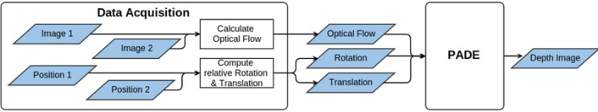
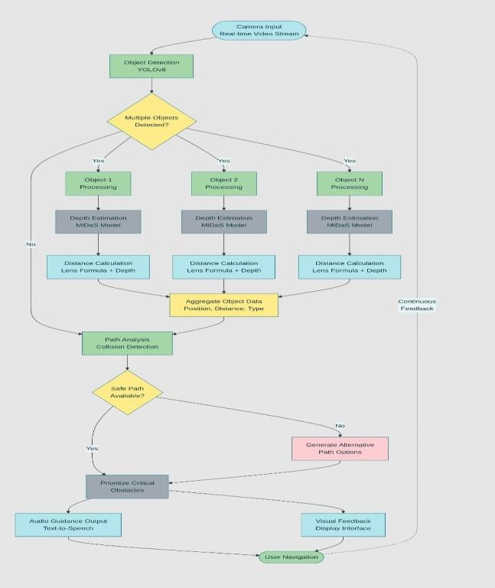
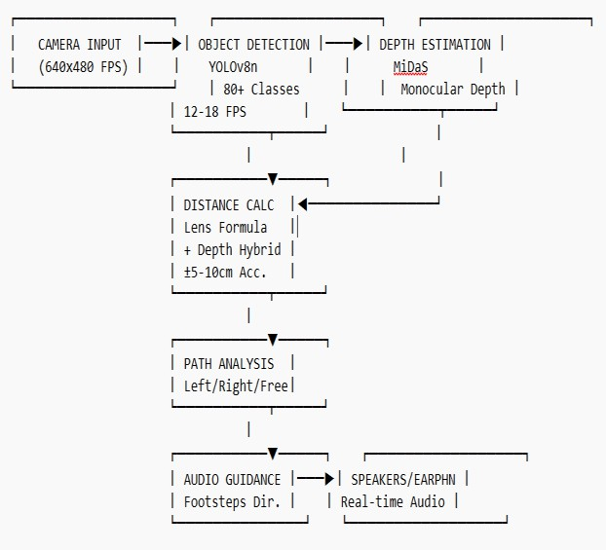

Fig. 1. Overall system architecture and data flow of the proposed framework.
A live RGB video stream captured from a monocular camera serves as the primary sensory input. The incoming frames are first processed by an object detection module to identify semantically relevant obstacles within the scene. For each detected object, depth estimation and distance computation are performed in parallel, enabling scalable processing of multiple obstacles. The aggregated spatial information is subsequently analyzed to determine collision risk and safe navigation paths. Finally, auditory guidance is synthesized and delivered to the user, closing the perception– action loop.
- Input Output Loop
The framework operates within a continuous input–output loop, wherein real-time video frames are processed to generate dynamic navigation instructions. The camera captures a live RGB video stream, which is concurrently analyzed by
multiple software modules. Based on the inferred spatial and semantic information, audio guidance is synthesized and delivered to the user through speakers or earphones. This loop executes continuously, ensuring adaptive navigation feedback as the user moves through the environment.
- Software Stack And Optimization
The software architecture employs the YOLOv8n (Nano) model for real-time object detection and the MiDaS_small model for monocular depth estimation. YOLOv8n is selected due to its anchor-free architecture and favorable trade-off between accuracy and computational efficiency, enabling the detection of over 80 object classes relevant to navigation scenarios.
To support real-time performance on CPU-only platforms, both models are optimized using ONNX-based quantization. A multi-threaded processing strategy is adopted to decouple video capture, inference, and audio synthesis stages, resulting in sustained performance of 12–18 frames per second (FPS) with minimal end-to-end latency.

- Proposed Methodology
The proposed methodology correlates semantic object information with spatial depth cues within a synchronized processing pipeline to facilitate safe navigation.
- Object Detection
Each incoming frame is processed by the YOLOv8 model to identify objects such as pedestrians, vehicles, furniture, and structural obstacles. The model’s anchor-free design enhances detection robustness for objects with irregular aspect ratios, including poles, stair edges, and narrow obstacles that are critical for collision avoidance.
- Depth Estimation
In parallel, the MiDaS model generates a pixel-wise relative depth map, providing structural awareness of the scene. This enables the system to detect potential obstacles even when they are not explicitly classified by the object detection module, thereby addressing the challenge of unclassified or partially occluded obstacles.
- Hybrid Distance Estimation
For detected objects, distance estimation is performed using a hybrid approach that combines geometric lens-based calculations for known object classes with inverse depth mapping derived from the monocular depth map. This fusion reduces scale ambiguity and improves metric distance accuracy in safety-critical regions near the user.
- Path Analysis And Feedback
The aggregated object data, including position, distance, and object type, is analyzed to determine collision risk and identify feasible navigation paths. When a safe path is available, the system prioritizes critical obstacles and generates intuitive audio instructions using a footstep-based reference model. If no safe path exists, alternative navigation cues are synthesized to guide the user away from hazards
- Hybrid Distance Estimation
- Overview
A key contribution of the proposed framework is a hybrid distance estimation model that recovers metric-scale depth from monocular visual data without relying on physical ranging sensors.
- Geometric Distance Estimation Using Thin Lens Model
For known object classes detected by YOLOv8, the distance D is estimated using a thin lens geometric model:

D = (f × H_real × H_image_res) / (H_pixel × H_sensor_phys)
Where,
f denotes the focal length of the camera lens obtained through calibration.
H_real represents the average real-world height of the detected object class.
H_image_res corresponds to the vertical resolution of the captured frame.
H_pixel is the height of the detected bounding box in pixels. H_sensor_phys is the physical height of the camera sensor in millimeters.
- Inverse Depth Mapping Using Monocular Estimation
For general scene structures and unclassified obstacles, the system employs inverse depth mapping derived from the MiDaS model:

D = k / (depth_value + ε )

Where,
k is a scaling constant calibrated using geometric distance estimates.
ε is a small constant added to prevent numerical instability.
- Accuracy And Calibration
The geometric estimates serve as reference anchors to scale the relative depth values produced by the MiDaS model. Experimental evaluation indicates a distance estimation accuracy of ±5–10 cm within a 0–2 m safety range, which is critical for obstacle avoidance during navigation.
D = (f × H × Ih) / (Ph × Sh) [Lens Formula]
D = k / depth_value [MiDaS Scaled]
- Navigation Logic And Audio Interface
- Path Analysis And Decision Logic
The perceived visual field is segmented into three spatial zones: left, center, and right. When an obstacle is detected within the central zone at a distance less than 1.5 m, the system evaluates the adjacent zones and selects the path with the maximum obstacle-free clearance
- Human Centric Foot-Step based guidance
To reduce cognitive load and improve interpretability, metric distances are converted into footstep-based units using an average human gait length of 0.75 m per step.
- Audio Guidance and Priority Scheduling
Audio feedback is delivered through a text-to-speech engine using a tiered alert mechanism.
- Priority 1 (Urgent): Hazards <1.0m (e.g., "STOP! Car less than 1 step away").
- Priority 2 (Warning): Hazards 1.0m - 3.0m (e.g., "Person ahead, 3 steps").
- Cooldown: A 2-second interval is enforced between non-urgent messages to prevent auditory fatigue and allow users to hear ambient environment cues.
- Experimental Results
The proposed framework was evaluated under real- world indoor and outdoor navigation scenarios using a monocular RGB camera and CPU-only inference. The system performance was measured across multiple safety- critical metrics, including object detection accuracy, inference speed, end-to-end latency, and distance estimation error. Particular emphasis was placed on the 0–2 m safety zone, which is most relevant for collision avoidance during assisted navigation.
Metric | Measured Value | Requirement for Safety
Detection Accuracy | 91.70% | > 85%
Average FPS | 12 - 18 FPS | > 10 FPS
Inference Latency | 350 – 500 ms | < 800 ms
Distance Error | ±5 - 10 cm | < 30 cm
Distance estimation accuracy was evaluated within the critical 0–2 m range, where precise spatial awareness is essential for preventing collisions. Experimental observations indicate that the proposed hybrid calibration approach successfully constrains distance estimation errors within ±5–10 cm, significantly outperforming the minimum safety threshold of 30 cm. These results demonstrate that software-based monocular calibration, when combined with geometric constraints, can achieve distance accuracy comparable to systems employing physical ranging sensors.
The optimized software pipeline achieved an average processing speed of 12–18 FPS on CPU-only hardware, with end-to-end inference latency consistently maintained below 500 ms. This confirms the suitability of the framework for real-time navigation assistance without reliance on specialized acceleration hardware.

- Conclusion And Future Scope
This paper presented Eyes for the Blinds, a pure software-based assistive navigation framework designed to enhance independent mobility for visually impaired individuals using only a monocular RGB camera and audio feedback. By integrating YOLOv8-based object detection with MiDaS monocular depth estimation, the proposed system delivers real-time semantic and spatial awareness without reliance on specialized ranging hardware.
A key contribution of this work is the proposed hybrid distance estimation model, which combines geometric lens- based calculations for known object classes with inverse depth mapping for general scene structures. Experimental evaluation demonstrated an average object detection accuracy of 91.7%, real-time operation at 12–18 FPS, and distance estimation errors constrained within ±5–10 cm in safety-critical zones. These results validate that software- only monocular approaches, when properly calibrated, can achieve performance comparable to hardware-assisted navigation systems.
Future work will focus on extending the framework to handle dynamic environments more effectively by incorporating object tracking to estimate relative motion and approach velocity of moving obstacles. Additional enhancements include integrating inertial measurement unit (IMU) data for fall detection and contextual awareness, as well as conducting large-scale user studies to evaluate usability, cognitive load, and long-term reliability in real- world navigation scenarios.
- Acknowledgment
The author, Ashutosh Rajesh Upadhyay, a postgraduate student, would like to express sincere gratitude to his project guide Mr. Rahul Bhandekar and co-guide Ms. Vijayta Dalwankar for their invaluable guidance, continuous support, and constructive feedback throughout the course of this research work. Their technical insights and encouragement were instrumental in shaping the development and successful completion of the Eyes for the Blinds project.
The author also extends appreciation to the faculty members of the Department of Computer Science and Engineering for providing a strong academic foundation and a supportive research environment. Gratitude is further expressed to the institution for providing the necessary resources and infrastructure required for experimentation and validation. Finally, the author acknowledges the encouragement and support received from peers and well-wishers during the course of this work.

Reference
- Performance Analysis of Deep Learning Object Detection Models for Visually Impaired - UEF eRepo, accessed on January 10, 2026, https://erepo.uef.fi/bitstreams/7d5edc65-c006-45ee-806c- 77960603c759/download
- International Journal of Research Publication and Reviews - ijrpr, accessed on January 10, 2026, https://ijrpr.com/uploads/V6ISSUE11/IJRPR55281.pdf
- An Audio Augmented Reality Navigation System for Blind and Visually Impaired People Integrating BIM and Computer Vision - MDPI, accessed on January 10, 2026, https://www.mdpi.com/2075- 5309/15/18/3252
- (PDF) Smart Assistive Navigation System for Visually Impaired People - ResearchGate, accessed on January 10, 2026, https://www.researchgate.net/publication/394462024_Smart_Assist ive_Navigation_System_for_Visually_Impaired_People
- Smart assistive navigation system for visually impaired people - The UWS Academic Portal, accessed on January 10, 2026, https://research portal.uws.ac.uk/en/publications/smart-assistive- navigation-system-for-visually-impaired-people
- Understanding Focal Length and Field of View - Edmund Optics, accessed on January 14, 2026, https://www.edmundoptics.com/knowledge-center/application- notes/imaging/understanding-focal-length-and-field-of-view/
- Thin-Lens Equation:Cartesian Convention - HyperPhysics, accessed on January 14, 2026, http://hyperphysics.phy- astr.gsu.edu/hbase/geoopt/lenseq.html
- Depth Map Decomposition for Monocular Depth Estimation, accessed on January 14, 2026, [2601.01457]
- Language as Prior, Vision as Calibration: Metric Scale Recovery for Monocular Depth Estimation - arXiv, accessed on January 14, 2026, https://arxiv.org/abs/2601.01457
- Zero-shot Monocular Metric Depth Estimation via Test-time Adaptation - NIPS papers, accessed on January 14, 2026, https://papers.nips.cc/paper_files/paper/2024/file/bd19ca8039547b3 39a6a37bd4df24405-Paper-Conference.pdf
- Survey on Monocular Metric Depth Estimation - MDPI, accessed on January 14, 2026, https://www.mdpi.com/2073-431X/14/11/502
- Assessing the implementation of user-centred design standards on assistive technology for persons with visual impairments: a systematic review - PubMed Central, accessed on January 14, 2026, https://pmc.ncbi.nlm.nih.gov/articles/PMC10511648/
- Challenges and Opportunities of the Human-Centered Design Approach: Case Study Development of an Assistive Device for the Navigation of Persons With Visual Impairment | Request PDF - ResearchGate, accessed on January 14, 2026, https://www.researchgate.net/publication/394547966_Challenges_a nd_Opportunities_of_the_Human- Centered_Design_Approach_Case_Study_Development_of_an_Ass istive_Device_for_the_Navigation_of_Persons_With_Visual_Impai rment
- Beyond the Cane: Describing Urban Scenes to Blind People for Mobility Tasks - PMC - NIH, accessed on January 14, 2026, https://pmc.ncbi.nlm.nih.gov/articles/PMC9491388/

